Gaining Great Rewards for Easy Actions in Islam
The Hadeeth of the Prophet which were chosen For their great rewards for easy actions
- Home
- [About this Blog]
- [References]
- [SlideShow]
- [All Posts]
- [Contact Us]
- [Others]

AsSalam Alaikum wa Rahmatullah. Ads may be displayed some times for non-logged in users. These ads are not by me and they are by wordpress.com and we donot have any control on these. To avoid the fitnah of these advertisements, I request brothers and sisters to login to wordpress while browsing the blogs. Another option is to enable No-ads plugin for your browser. Barakallaah Feekum. wa salam alaikum wa rahmatullah

Day of Jumu’ah – Ask Allaah for Anything in the Last Hour after ‘Asr
September 21, 2012 AbdurRahman.org Leave a comment
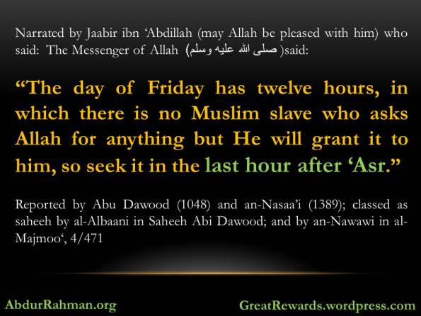
Narrated by Jaabir ibn ‘Abdillah (may Allah be pleased with him) who said:
The Messenger of Allah (صلى الله عليه وسلم) said:
“The day of Friday has twelve hours, in which there is no Muslim slave who asks Allah for anything but He will grant it to him, so seek it in the last hour after ‘Asr.”
Reported by Abu Dawood (1048) and an-Nasaa’i (1389); classed as saheeh by al-Albaani in Saheeh Abi Dawood; and by an-Nawawi in al-Majmoo‘, 4/471
Related Links:
- The Hour on Friday in which the Supplication From a Muslim is Accepted
- Get your Minor Sins forgiven between Friday and the following Friday

Share this:
- Email
- Twitter45
- Facebook53
- LinkedIn2
- More

Categories: Dua, Great-Rewards-in-Islam Tags: friday, Great Rewards, Hour of Response, Islam, Jumu'ah, supplication

Shaking Hands with Believer
July 10, 2012 AbdurRahman.org Leave a comment
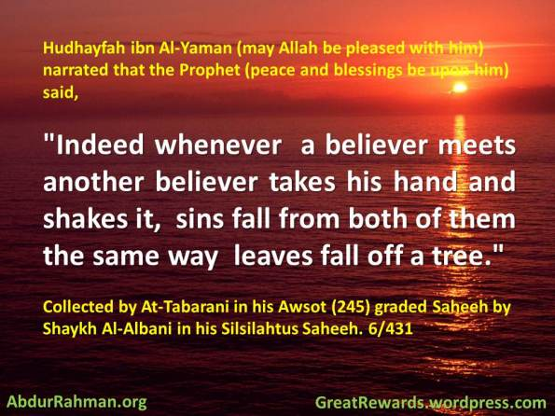
Hudhayfah ibn Al-Yaman (may Allah be pleased with him) narrated that the Prophet (peace and blessings be upon him) said, ” Indeed whenever a believer meets another believer takes his hand and shakes it, sins fall from both of them the same way leaves fall off a tree.”
Collected by At-Tabarani in his Awsot (245) graded Saheeh by Shaykh Al-Albani in his Silsilahtus Saheeh. 6/431
Benefits about this topic:
Shaykh Al-Albani 1421H (may Allah rest him in Jannah) wrote in Silsilahtus Saheeh; It is sunnah to take a person’s hand and shake it. And to take both a person’s hands and shake them is contradictory to the sunnah; like some of the mashaykh do.
Shaking hands is a legislated act at the time of parting as well.
It is an innovation to shake hands directly after the prayer.(end of quote from Shaykh Nasir.[ 1/ 52] )
Al-bara’ ibn ‘Aazib (may Allah be pleased with him) said,” Shaking hands is a complete greeting.” [ # 968 Saheeh Adabul Mufrad]
The first people to introduce the handshake were the people from Yemen [ # 967 Saheeh Adabul Mufrad by Imam Al-Bukhari]
http://salafitalk.net/st/viewmessages.cfm?Forum=11&Topic=7175

Share this:
- Email
- Twitter9
- Facebook33
- LinkedIn1
- More

Categories: Character, Great-Rewards-in-Islam Tags: Allah, Believer, handshake, Islam, Shaking Hands, Sunnah

There is no Muslim who plants a plant or a tree, except that whatever is eaten from it is a charity for him
June 14, 2012 AbdurRahman.org Leave a comment
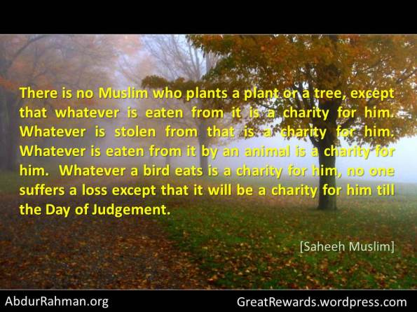
7 – From Anas the Prophet -sallAllaahu alayhi wa sallam- said:
‘There is no Muslim who plants a plant or a tree, or sows a seed and no bird, or human or animal eats from that except that it is a charity for that person.’
[Collected by Bukhari, Muslim & Ahmad]
8 – From Jabir from the Prophet -sallAllaahu alayhi wa sallam:
‘There is no Muslim who plants a plant or a tree, except that whatever is eaten from it is a charity for him. Whatever is stolen from that is a charity for him. Whatever is eaten from it by an animal is a charity for him. Whatever a bird eats is a charity for him, no one suffers a loss except that it will be a charity for him till the Day of Judgement.’
[Collected by Muslim]
No. 9 – From Anas -Radi Allaahu anhu- from the Prophet -sallAllaahu alayhi wa sallam- said:
‘If the final hour comes and one of you has a small date-palm plant in his hand, and if you can plant it before you stand then plant it.’
Check the Below for further reading:
- The Encouragement in Islaam to Utilize the Land & to Till the Land
Taken from ‘Silsilah Ahadeeth As-Saheehah’, By the Muhaddith, Shaykh, Allamaa’ Muhammad Nasir uddeen al-Albaani

Share this:
- Email
- Twitter5
- Facebook42
- LinkedIn
- More

Categories: Charity, Great-Rewards-in-Islam Tags: Abbas Abu Yahya, Cultivation, Islam, land, Muhammad Nasiruddin al-Albani, Muslim, planting, plants, Prophet, salaf, till, tree, Umar

Whoever says ten times immediately after finishing the Fajr/Maghrib Prayer ..
June 11, 2012 AbdurRahman.org 1 comment
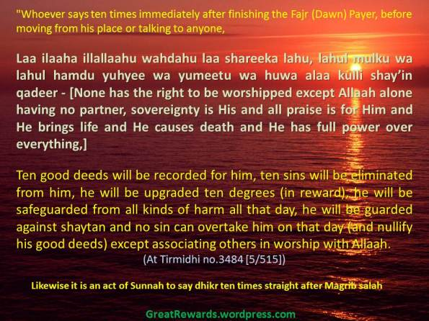
On the authority of Abu Dharr (radiAllahu anhu), that the Prophet (sallAllahu alayhi wasallam) said -
“Whoever says ten times immediately after finishing the Fajr (Dawn) Payer, before moving from his place or talking to anyone,
“laa ilaaha illallaahu wahdahu laa shareeka lahu, lahul mulku wa lahul hamdu yuhyee wa yumeetu wa huwa alaa kulli shay’in qadeer – [ none has the right to be worshipped except Allaah alone having no partner, sovereignty is His and all praise is for Him and He brings life and He causes death and He has full power over everything,]”
ten good deeds will be recorded for him, ten sins will be eliminated from him, he will be upgraded ten degrees (in reward), he will be safeguarded from all kinds of harm all that day, he will be guarded against shaytan and no sin can overtake him on that day (and nullify his good deeds) except associating others in worship with Allaah. (At Tirmidhi no.3484 [5/515])
At-Tirmidhi commented on this hadeeth saying, “This is a hasan, saheeh hadeeth (i.e a good and authentic hadeeth)”.
Likewise it is an act of Sunnah to say dhikr ten times straight after Magrib salah too, according to a hadith related by Imaam Ahmad Hanbal (rahimahullah) on the authority of Umm Salamah (radiAllahu anha), hadith number 26430. Also stated in Sahih Ibn Hibban no. 2023.
Source : A Summary of Islamic Jurisprudence – Dr. Salih al-Fawzaan, Volume 1 , Chapter 10

Share this:
- Email
- Twitter47
- Facebook90
- LinkedIn1
- More

Categories: Dhikr, Masjid, Salah, Shytan, Sins Forgiven Tags: Dhikr, Expiation of Sins, Fajr, Great Reward, Islam, islamic jurisprudence, Muslim, Prayer, shaytan, Sunnah

Great Reward of doing aqiqah for your children
March 21, 2012 AbdurRahman.org 5 comments
Fathers whose Children will Intercede for Them on the Day of Judgement
by Ahmed Abu Turaab @ http://wp.me/p1lJtd-JT
Questioner: What kind of intercession is it that a child will do for his father when his father was someone who had given an aqiqah on behalf of that child? [The Aqiqah being the Sunnah of sacrificing two sheep for the new-born boy and one for the girl]
Al-Albaani: It is known in many hadiths that on the Day of Resurrection there will be young children standing at the gate of Paradise, crying and asking for their fathers. So Allaah the Blessed and Most High will send Jibreel عليه السلام to ask them why they are crying–even though He the Blessed and Most High knows better about them–so Jibreel عليه السلام will ask them and they will reply, saying, ‘We will not enter Paradise except that our fathers are with us.’ So the Lord of the Worlds will give permission to them and their fathers to enter Paradise.
So this type of intercession, i.e., hastening entry into Paradise, is what those fathers who offered aqiqah’s on behalf of their children, i.e., sacrificed on their behalf when they were born, deserve.
Al-Huda wan-Noor, no. 16.
Related Links:
- [Ahadeeth] Sacrifice on Occasion of Birth (`Aqiqa) – Sahih Bukhari

Share this:
- Email
- Twitter10
- Facebook36
- LinkedIn2
- More

Categories: Great-Rewards-in-Islam Tags: aqiqah, day of judgement, day of resurrection, Islam

Charity is Due On Every Joint Bone Of The Body
January 18, 2012 AbdurRahman.org 2 comments
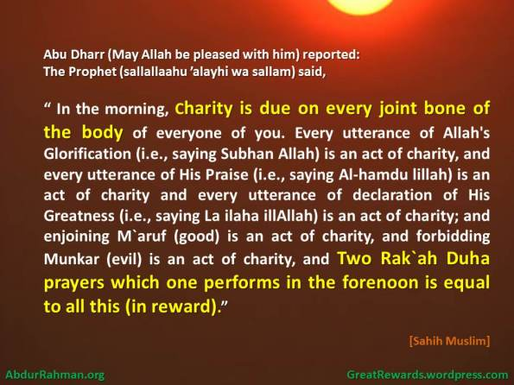
Abu Dharr (May Allah be pleased with him)reported: The Prophet (sallallaahu ’alayhi wa sallam) said, “In the morning, charity is due on every joint bone of the body of everyone of you. Every utterance of Allah’s Glorification (i.e., saying Subhan Allah) is an act of charity, and every utterance of His Praise (i.e., saying Al-hamdu lillah) is an act of charity and every utterance of declaration of His Greatness (i.e., saying La ilaha illAllah) is an act of charity; and enjoining M`aruf (good) is an act of charity, and forbidding Munkar (evil) is an act of charity, and two Rak`ah Duha prayers which one performs in the forenoon is equal to all this (in reward).” [Muslim].
Commentary: “Charity is due from every joint bone” means that when a person gets up in the morning, it is obligatory for him to thank Allah for having every joint of his intact. Therefore, one must praise and glorify Allah. Since a single invocation of the words mentioned in this Hadith is equivalent to one Sadaqah, one must say these words for 360 times – a number which equals the number of joints in man’s body. Moreover, to enjoin someone to do what is good and dissuade somebody from vice constitutes Sadaqah. However, if one performs two Rak`ah of Duha prayer, it will serve for Sadaqah for all the joints of the body. Thus, this Hadith highlights the merits and importance of Duha prayer. We also learn from this Hadith that Sadaqah is not restricted to spending money alone but also has a vast meaning and covers all forms of virtues mentioned here.
Source of the above : Merit of the (Optional) Duha (Forenoon) Prayer – Riyadh ul Saleheen
Related Links:
- Time for the Duha (Forenoon Optional) Prayer – Riyadh ul Saleheen
- Fatawa related to Duha Prayer – Permanent Committee Fatwas
- Superegatory Prayers ( Sunnat Muakkadah & other Nawafil Prayers)

Share this:
- Email
- Twitter7
- Facebook36
- LinkedIn
- More

Categories: Great-Rewards-in-Islam, Salah Tags: Allah, Charity, Duha, forenoon, joints of the body, Sadaqah, Salah

Preserve These Eight Rak’ah and Stay Out Of Hell – By the Will of Allaah!
January 14, 2012 AbdurRahman.org 4 comments
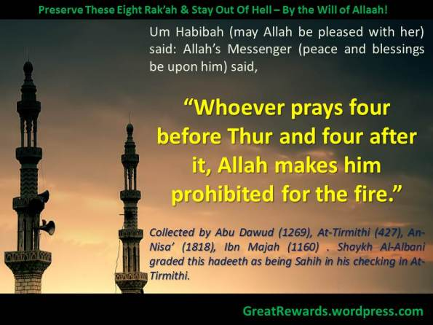
Um Habibah (may Allah be pleased with her) said: Allah’s Messenger (peace and blessings be upon him) said, “Whoever prays four before Thur and four after it, Allah makes him prohibited for the fire.” Collected by Abu Dawud (1269), At-Tirmithi (427), An-Nisa’ (1818), Ibn Majah (1160) . Shaykh Al-Albani graded this hadeeth as being Sahih in his checking in At-Tirmithi.
Benefits for this topic:
• There are three narrations for this hadeeth, “ He won’t touch the fire”, “Allah makes him prohibited for the fire” , and “Allah makes his flesh prohibited for the fire”.
• Shaykh Abdullah ibn Salih Al-Fawzan (may Allah preserve him) said, “This hadeeth shows the virtue of these four rak’at before and after Thur. These eight Rak’at are a means to be saved from Hell, along with carrying out obligations, and avoiding prohibitions. Doing this act is simple and easy for the Muslim, when he practices and trains the soul to do it.[ Minhatul ‘Alam fi Sharhi Bulughil Maram]
• Imam Ash-Shawkani (may Allah have mercy on him) wrote : “ The people differ over the meaning of this hadeeth. Some people say it means “he won’t enter the fire at all”, and others say, “If he enters the fire it won’t consume him”. Then there are some people who say it means, “The fire won’t consume him totally, but only part of his body, if he enters it.” It’s better to carry this hadeeth on its apparent meaning: Allah will make his entire body prohibited from the fire. Allah’s Mercy is vast. [Nayl]
• There is another narration, which in the beginning states, “Whoever preserves four Rak’at for Thur…” It’s understood here that this protection is awarded to the person who regularly practices these eight Rak’at.” [ Shaykh Muhammad Adam Sharh Sunnan An-Nisa’I vol 18/199]
• As-Sindee (may Allah have mercy on him) said, “It’s enough to have belief in this hadeeth as it’s been mentioned. Perhaps the person who regularly practices this act will be granted from Allah success and have all his sins forgiven.” [ Sharhul Ibn Majah]
The description for this prayer
• At-Tirmithi, “Some people of knowledge said that prayer for the day and night is two by two; they believed that one should separate between every two Rak’ah. This is the view of Ash-Shafa’I and Ahmad.” [Jam’I At-Tirmithi #424]
• Al-Hajjawi (may Allah have mercy on him) said, “If a person prays the voluntary prayers during the day time in four Rak’ah like Thur, then there is no problem with that.” Al-Alammah Bin Baz (may Allah have mercy on him) said,” This view is weak. What’s correct is two by two.” [Ta’leeqat Bin Baz ‘ala Zad’]
• The Prophet (peace and blessings be upon him) said,” The prayers during the day and night are two by two.” [ collected by Abu Dawud 1172 Al-Bukhari and Al-Albani both graded this hadeeth as being Saheeh]
• Based on the above hadeeth the prayers during the night and day are two by two. A person makes Tasleem after completing two rak’ah. Furthermore a principle is built off this is that every hadeeth that mentions the wording four without clearly stating the denial of a tasleem, then it’s a must to consider it being he (peace and blessings be upon him) prayed it two by two.”[ Al-Mumt’I vol 4/77]
• Abdul Malik Al-Juwaynee ([478H] May Allah have mercy on him) said, “All voluntary prayers are two by two, except Witr, regardless day or night.” [Nihayatul Matlube 3/ 349]
Translated and compiled by Abu Aaliyah Abdullah ibn Dwight Battle Sr.
Doha, Qatar Rabbil Awal 15/1431
http://AbuAaliyah.multiply.com
Related Links:
- Sunnah of Zuhr Prayer – Riyadh ul saaliheen

Share this:
- Email
- Twitter25
- Facebook118
- LinkedIn1
- More

Categories: Great-Rewards-in-Islam, Jannah wan Naar, Salah Tags: Duhr, Hell, Namaz, Salah, Sunnah, Thur, Voluntary Prayers, Zuhr
Gaining Great Rewards for Easy Actions in Islam
Blog at WordPress.com. Theme: INove.

The Tremendous Virtue of Reciting Soorat al-Ikhlaas 10 Times
January 14, 2012 AbdurRahman.org Leave a comment
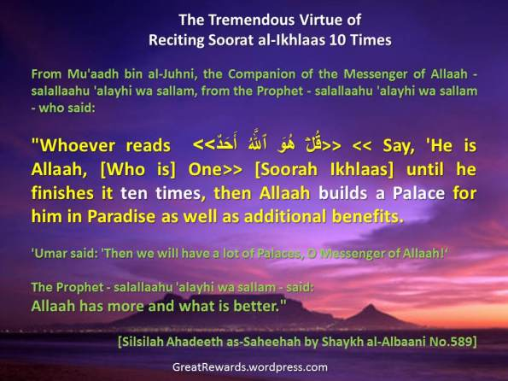
Some Ahadeeth Regarding Particular Ayaat of the Qur`aan
From Mu’aadh bin al-Juhni, the Companion of the Messenger of Allaah – salallaahu ‘alayhi wa sallam, from the Prophet – salallaahu ‘alayhi wa sallam – who said:
“Whoever reads <<قُلۡ هُوَ ٱللَّهُ أَحَدٌ>> << Say, ‘He is Allaah, [Who is] One>> [Soorah Ikhlaas] until he finishes it ten times, then Allaah builds a Palace for him in Paradise as well as additional benefits.
‘Umar said: ‘Then we will have a lot of Palaces, O Messenger of Allaah!’
The Prophet – salallaahu ‘alayhi wa sallam – said: Allaah has more and what is better.” [Silsilah Ahadeeth as-Saheehah by Shaykh al-Albaani No.589]
Source: Click on the linked part of the headline, or here. Here is the homepage of this highly beneficial website of our beloved brother Abbas Abu Yahya (hafidhahullaah).

Share this:
- Email
- Twitter
- Facebook
- LinkedIn
- More

Categories: Great-Rewards-in-Islam, Jannah wan Naar, Qur'an Tags: Great Rewards, Ikhlaas, Jannah, Palace, palaces, Qur'an

From the Benefits of the Sittings of Knowledge
December 25, 2011 AbdurRahman.org Leave a comment
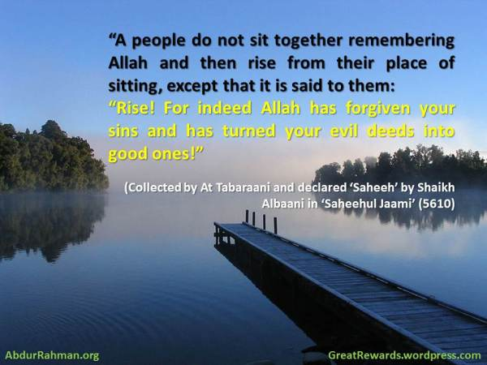
Bismillah Wal Hamdullillah Was Salaatu Was Salaamu ‘Alaa Rasoolillahi
Ammaa Ba’d:
Since many of our brothers are here in the Birmingham Dawra we remind of the following hadeeth that mentions one of the fruits of attending sittings of knowledge.
Upon the authority of Sahl Ibn Handhalah – Radhiyallahu ‘anhu who said: “The messenger of Allah – Sallallahu ‘Alaihi was Salam said:
“A people do not sit together remembering Allah and then rise from their place of sitting, except that it is said to them: “Rise! For indeed Allah has forgiven your sins and has turned your evil deeds into good ones!”
(Collected by At Tabaraani and declared ‘Saheeh’ by Shaikh Albaani in ‘Saheehul Jaami’ (5610))
We ask Allah that he blesses all attendees with this khair
Wa Sallallahu Alaa Nabiyinaa Muhammad
www.twitter.com/abuhakeembilal
http://ah-sp.com/2011/12/24/from-the-benefit-of-the-sittings-of-knowledge/

Share this:
- Email
- Twitter
- Facebook
- LinkedIn
- More

Categories: Great-Rewards-in-Islam, Knowledge (ilm)

Never underestimate even the smallest charity!
December 11, 2011 AbdurRahman.org 3 comments
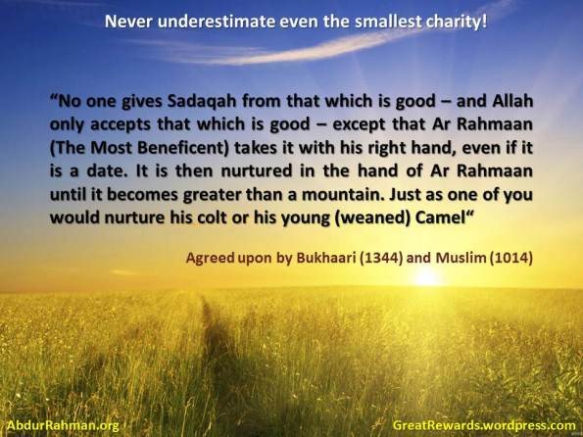
Bismillahi Wal Hamdullillah Was Salaatu Was Salaamu ‘Alaa Rasoolillahi
Ammaa Ba’d:
Upon the Authority of Abu Huraira – Radhiyallahu ‘Anhu who said: The messenger – Sallallahu ‘Alaihi Was Salam
“No one gives Sadaqah from that which is good – and Allah only accepts that which is good – except that Ar Rahmaan (the most beneficent) takes it with his right hand, even if it is a date. It is then nurtured in the hand of Ar Rahmaan until it becomes greater than a mountain. Just as one of you would nurture his colt or his young (weaned) Camel“
(Agreed upon by Bukhaari (1344) and Muslim (1014))
In variant wording:
Upon the authority of Aisha – Radhiyallahu ‘Anhaa – that the messenger of Allah – Sallallahu ‘alaihi wa Salam – said
“Indeed Allah nurtures for one of you the date and the morsel (that you give in charity) just as one of you nurtures his colt or young camel until it (the charity) becomes like (Mount) Uhud“
(Collected by Ibn Hibbaan (3302) and declared ‘Saheeh’ by Shaikh Al Albaani)
Al Mubaarakfoori mentions in ‘Tuhfatul Ahwadhi’ (3/264):
“In it is an indication of the fact that it will not be accepted if it is not Halaal. Al Qurtubi mentions: “Indeed Allah does not accept Charity from haraam, since it is not the possession of the one who gives it as charity.Thus he is prohibited from utilising it. So when the one who spends in charity is utilising what he is spending, if it were to be accepted from him, it would necessitate that it (i.e that charity) would be legislated and prohibited at the same time and that is impossible“
Wa Sallallahu ‘Alaa Nabiyyinaa Muhammad
Abu Hakeem Bilal Davis @ SP
http://ah-sp.com/2011/12/10/never-underestimate-even-the-smallest-charity/
Related Links :
- Parable of Spending in Allah’s Cause – Tafseer IbnKathir
- Don’t request du’aa in exchange for charity

Share this:
- Email
- Twitter
- Facebook
- LinkedIn
- More

Categories: Charity, Great-Rewards-in-Islam Tags: Charity

The Hour on Friday in which the Supplication From a Muslim is Accepted
December 9, 2011 AbdurRahman.org 1 comment
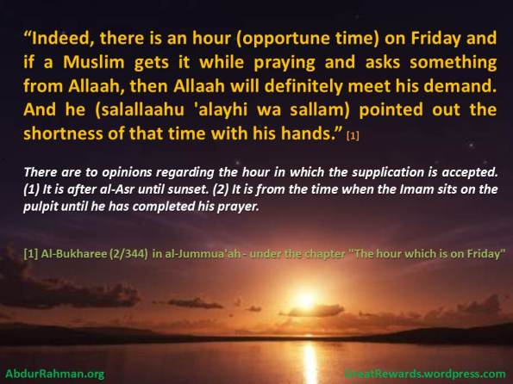
The Hour on Friday in which the Supplication From a Muslim is Accepted, by Imam Ibnul-Qayyim
Here is an excerpt from Ibnul Qayyim (rahimahullaah):
There is an hour of acceptance, and it is the hour in which no Muslim happens to supplicate to Allah for something except that it will be given to him. In the hadeeth reported by al-Bukharee and Muslim on the authority of Abu Hurayrah that Allaah’s Messenger (salallaahu ‘alayhi wa sallam)
said: Indeed, there is an hour (opportune time) on Friday and if a Muslim gets it while praying and asks something from Allah, then Allah will definitely meet his demand. And he (salallaahu ‘alayhi wa sallam) pointed out the shortness of that time with his hands.
Click here to read.

Share this:
- Email
- Twitter
- Facebook
- LinkedIn
- More

Categories: Dua, Great-Rewards-in-Islam, Masjid Tags: Allaah, friday, Islam, Jumu'ah

Oh Allaah forgive your servant for indeed he spent the night in a state of purity
December 9, 2011 AbdurRahman.org Leave a comment
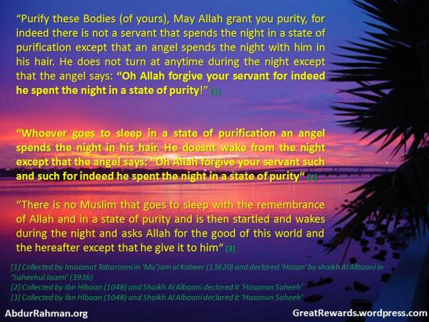
The Virtue of Sleeping in Wudhoo
Bismillahi Wal Hamdullillah Was Salaatu Was Salaamu ‘Alaa Rasoolillahi
Ammaa Ba’d:
Upon the authority of Ibn Umar -Radhiyallahu ‘Anhumaa -who said that the Messenger – Sallallahu ‘Alaihi Was Salam Said:
“Purify these Bodies (of yours), May Allah grant you purity, for indeed there is not a servant that spends the night in a state of purification except that an angel spends the night with him in his hair. He does not turn at anytime during the night except that the angel says: “Oh Allah forgive your servant for indeed he spent the night in a state of purity!”
(Collected by Imaamut Tabaraani in ‘Mu’jam al Kabeer (13620) and declared ‘Hasan’ by shaikh Al Albaani in ‘Saheehul Jaami’ (3936))
Upon the authority of Ibn Umar – Radhiyallahu ‘Anhumaa who said that the messenger -Sallallahu ‘Alaihi Was Salam said:
“Whoever goes to sleep in a state of purification an angel spends the night in his hair. He doesnt wake from the night except that the angel says: “Oh Allah forgive your servant such and such for indeed he spent the night in a state of purity“
(Collected by Ibn Hibaan (1048) and Shaikh Al Albaani declared it ‘Hasanun Saheeh’
Upon the authority of Mu’aadh Ibn Jabal – Radhiyallahu ‘Anhu - who narrated upon the authority of the messenger – Sallallahu Alaihi Was Salam – Who said:
“There is no Muslim that goes to sleep with the rememberance of Allah and in a state of purity and is then startled and wakes during the night and asks Allah for the good of this world and the hereafter except that he give it to him“
(Collected by Abu Daawood 5042 and declared ‘Saheeh’ by Shaikh Al Albaani)
These narrations then establish the following:
- The Dua of the angel as he stirs and moves during his sleep
- The Dua of the angel for him when he wakes
- His Dua being accepted if he supplicates for the good of the dunya and the hereafter when he is startled during the night, if he sleeps upon the rememberance of Allah and in a state of purification.
Wa Billahit Tawfeeq
Abu Hakeem Bilal Davis
http://ah-sp.com/2011/12/09/the-virtue-of-sleeping-in-wudhoo/

Share this:
- Email
- Twitter
- Facebook
- LinkedIn
- More

Categories: Dhikr, Great-Rewards-in-Islam, Tahara Tags: Allah, angel, Dua, Muslim, sleep, tahara, wudhu

He who equips a Ghazi (fighter) in the way of Allah
December 2, 2011 AbdurRahman.org Leave a comment
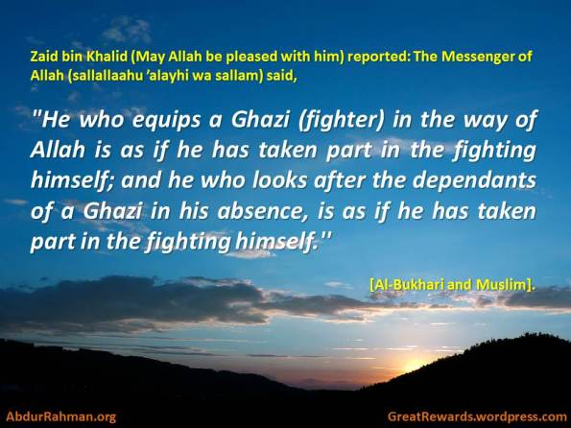
Zaid bin Khalid (May Allah be pleased with him) reported: The Messenger of Allah (sallallaahu ’alayhi wa sallam) said,
“He who equips a Ghazi (fighter) in the way of Allah is as if he has taken part in the fighting himself; and he who looks after the dependants of a Ghazi in his absence, is as if he has taken part in the fighting himself.”
[Al-Bukhari and Muslim].

Share this:
- Email
- Twitter
- Facebook
- LinkedIn
- More

Categories: Great-Rewards-in-Islam, Jihad Tags: jihad

Allaah will surely tear open the sky until He looks at the person from amongst the people of the earth who said it!
December 1, 2011 AbdurRahman.org Leave a comment
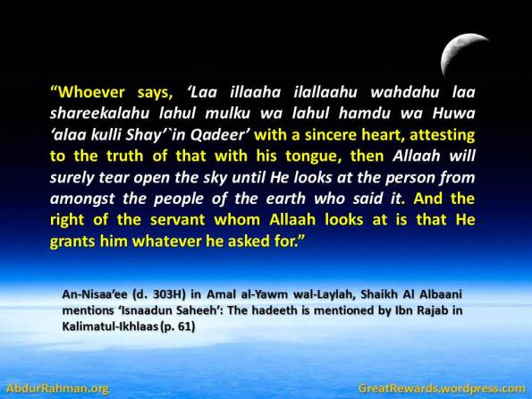
There occurs from An-Nisaa’ee (d. 303H) in Amal al-Yawm wal-Laylah,
The hadeeth of two men from amongst the companions, from the Prophet (salallaahu ‘alayhi wa sallam):
“Whoever says, ‘Laa illaaha ilallaahu wahdahu la shareekalahu lahul mulku wa lahul hamdu wa Huwa ‘ala kulli Shay’`in Qadeer’ with a sincere heart, attesting to the truth of that with his tongue, then Allaah will surely tear open the sky until He looks at the person from amongst the people of the earth who said it. And the right of the servant whom Allaah looks at is that He grants him whatever he asked for.”
Shaikh Al Albaani mentions ‘Isnaadun Saheeh’: The hadeeth is mentioned by Ibn Rajab in Kalimatul-Ikhlaas (p. 61)
There Also occurs upon the authority of Abu Huraira (Radhiyallahu ‘anhu) who said that the messenger (Sallallahu alahi wa salam) who said:
“No servant says Laa ilaha illallah sincerely, except that the heavens open up for it and it ascends until it reaches the throne, providing one stays away from the major sins”
Shaikh Naasir Mentions: ‘Isnaadun Hasan’ Kalimatul Ikhlaas P60
Source : Posted by Abu Hakeem Bilal Davis @ http://ah-sp.com

Share this:
- Email
- Twitter
- Facebook
- LinkedIn
- More

Categories: Dhikr, Great-Rewards-in-Islam
RSS feed

Twitter
Just Subscribe to My Google Group (http://groups.google.com/group/abdurrahmanorg/) and get updates of all my Blogs Posts in your email
My Website and Blogs
AbdurRahman.org
Salaf-us-Saalih.com
Shayaateen.wordpress.com
AsmaWaSifaat.wordpress.com
Invitation2Islaam.wordpress.com
NewToIslaam.wordpress.com
GreatRewards.wordpress.com
CoveredPearls.wordpress.com
NobleQuraan.wordpress.com
AhlulBidah.wordpress.com
MuslimFortress.wordpress.com
SalahOnline.wordpress.com
SinsInIslam.wordpress.com
TheSalafee.wordpress.com
QuotesOfSalaf.wordpress.com
DailyHadeeth.wordpress.com
SalafiAudio.wordpress.com
TeluguIslam.net
My Islamic app on Android and Nokia OVI Download this blog as PDF

Follow Blog via Email

Enter your email address to follow this blog and receive notifications of new posts by email.
Join 190 other followers

Categories
- Character (6)
- Charity (2)
- Dhikr (18)
- Dua (24)
- Fasting (4)
- Great-Rewards-in-Islam (78)
- Hajj (3)
- Jannah wan Naar (7)
- Jihad (3)
- Knowledge (ilm) (3)
- Masjid (8)
- Qur'an (8)
- Ramadhan (5)
- Salah (23)
- Shytan (5)
- Sins Forgiven (7)
- Tahara (3)

Recent Posts
- Day of Jumu’ah – Ask Allaah for Anything in the Last Hour after ‘Asr
- Shaking Hands with Believer
- There is no Muslim who plants a plant or a tree, except that whatever is eaten from it is a charity for him
- Whoever says ten times immediately after finishing the Fajr/Maghrib Prayer ..
- Great Reward of doing aqiqah for your children
- Charity is Due On Every Joint Bone Of The Body
- Preserve These Eight Rak’ah and Stay Out Of Hell – By the Will of Allaah!
- The Tremendous Virtue of Reciting Soorat al-Ikhlaas 10 Times
- From the Benefits of the Sittings of Knowledge
- Never underestimate even the smallest charity!

Gaining Great Rewards for Easy Actions
Hadeeth taken from ‘Saheeh al-Kalima at-Tayyib’, By Shaykhul Islaam Ibn Taymeeyah , Checked by Muhammad Nasir-rudeen al-Albani

The Precious Remembrance - ash-Shaykh Ibn ‘Uthaymeen
A comprehensive collection of morning and evening supplications written by the hand of al-Faqih, al-‘Alaamah, az-Zaahid: Muhammad bin Saalih al-‘Uthaymeen (may Allah have mercy upon him)

Twitter Updates
- Nightmares and bad dreams are from Shaytan wp.me/p1M177-bO via @AbdurRahmanOrg 18 hours ago
- A Sister asks Shaykh al-Fawzan the Cure for Worry and Stress wp.me/p1QF7B-9u via @AbdurRahmanOrg 18 hours ago
- Great Supplication ! Memorize this !! - The Du'aa of Light (Noor) wp.me/p1Z8C1-cL via @AbdurRahmanOrg 18 hours ago
- Never underestimate even the smallest charity! - [Tremondous Benefit] wp.me/p1FIuh-b2 via @AbdurRahmanOrg 18 hours ago
- On Eid al-Adha it is mustahabb not to eat anything until one comes back from the eid prayer. 2 days ago

Top Posts & Pages
- Never underestimate even the smallest charity!
- Excellent dua to Allaah asking cure for sick person
- Whoever says ten times immediately after finishing the Fajr/Maghrib Prayer ..
- Great Reward of doing aqiqah for your children
- Shaking Hands with Believer
- The Tremendous Virtue of Reciting Soorat al-Ikhlaas 10 Times

salaf-us-saalih.com
- Arriving Late For The ‘Eid Prayer – Permanent Committee for Research and Verdicts
- Hajj 2012 Live – http://makkahlive.net/hajj2012.aspx
- Buying a “Sacrifice” via Various Charitable Organisations to be Slaughtered Abroad for the Poor?
- Calling All Responsible Websites: Advice and Reminders
- The Meaning of Allaahu Akbar!

Asma wa Sifaat
- The Meaning of Allaahu Akbar!
- Was ‘Eesaa ‘alaihissalaam Allaah’s Word? – Shaykh ibn Uthaymeen
- The Most Beautiful Thing That the People of the World Leave the World Without Ever Tasting
- My Young Daughter Constantly asks me, ‘Why can’t we see Allah in this life?’
- Errors of the Rafidah on Tawhid of Allah’s Names and Attributes – Sheikh Ali ibn Yahya al-Haddaadee

As Salah (The Prayer)
- How one in Salat replies to Salaam, in accordance with Sunnah
- Sneezing then Praising Allah while being led in Prayer – Shaykh ‘Abdul-‘Azeez Aali ash-Shaykh
- In the Salah, Put your Hand on your Heart, is this Correct ?
- Where do we put our hands after Rukoo’? | Shaikh Zayd ibn Hadee al-Madkhalee
- How to Deal With the Elderly Person Who Does Not Pray or Commits Acts of Disobedience

Fortress of the Muslim
- Scholarly comments on morning and evening (dhikr) timings
- Ask Allah Ask Allah! - Abu 'Abdis Salaam Siddiq Al Juyaanee [Mp3|En]
- O my Lord! Make me one who performs As-Salât (Iqâmat-as-Salât ), and (also) from my Offspring
- Asking Allaah for Taqwa and Purification of the Soul
- Iblees comes and says: ‘How much did you call upon Him and did not see any response?’

Jinn & Shayaaten
- Shaykh Abdullah al-Ghudayaan & The Jinn – Mustafa George
- What is the proof to divide the Jinn Salafis and non-Salafis – Shaykh Muqbil al-Waadi’ee
- How do the Jinn come inside of you? - Abu Khadeejah [Mp3|Eng]
- Shaytaan Promised to take as many of us Astray as he could - Shaykh Ahmad 'Umar Bazmool (mp3/arabic-english)
- If Iblees conquers the son of Adam with one of the three...

Covered Pearls
- What is better for a woman, to come out to the Eid prayer or to stay at home?
- “Jealousy Of The Women” By: Umm Abdillah al-Waadi’iyaah bint Muqbil ibn Haadee - Hasan Somalee [Mp3|En]
- Women Wearing Hijab And Make-up In Public: Two Conflicting Contradictions In Islam - Shaykh Albanee [Arabic/English]
- Women who show their Awrah to other Women at Weddings - Shaykh Saalih al-Fawzaan [Arabic/English]
- Umm Sulaym (radhi Allaahu Anha) - Abu Khadeejah [Mp3|En]

Meta
- Register
- Log in
- Entries RSS
- Comments RSS
- WordPress.com

Blog Stats
- 84,119 hits

Follow

Follow “Gaining Great Rewards for Easy Actions in Islam”

Get every new post delivered to your Inbox.
Join 190 other followers

Powered by WordPress.com

